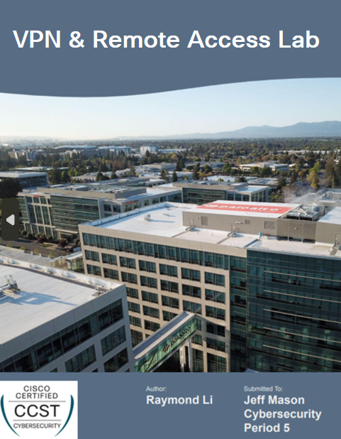

**Purpose:**

The goal of this lab was to allow for a device outside the network to remotely connect to a device within the internal network. On top of that, this connection must be performed in a secure manner (which we do through the GlobalProtect VPN). The purpose of our lab is to set up the necessary configurations for GlobalProtect and remote access using authentication, encryption, and firewall policies.

**Background:**

GlobalProtect is a VPN solution designed by Palo Alto Networks that can provide secure remote access on large scale networks. The basic structure consists of a portal, which manages authentication, and a gateway, which provides the encrypted VPN tunnel. GlobalProtect also applies other typical cybersecurity tools, such as enforcing security policies, inspecting traffic, and hosting integrity checks.

Remote Desktop is a mechanic that allows users to access and control a different device using their current device over a network, provided that they are authenticated. It is commonly used in IT so that users can access resources stored in different locations.

Security zones are designed areas within a firewall’s system where a series of logical rules can be applied to separate network traffic. Typically, interfaces are the primary subject that zones are applied to so that unauthorized communication over the network can be prevented.

**Lab Summary:**

The first part of our lab involves generating certificates that is useful to the device outside our network so that it can be trusted. Our lab then walks through configuring the GlobalProtect Portal and Gateway to work with a Dynamic DHCP Client. Lastly, we download the GlobalProtect VPN and permit remote access on our device.

**Lab Procedure:**

1. Go to Device > Certificate Management > Certificates > Device Certificates. Click the “Generate” on the bottom bar.

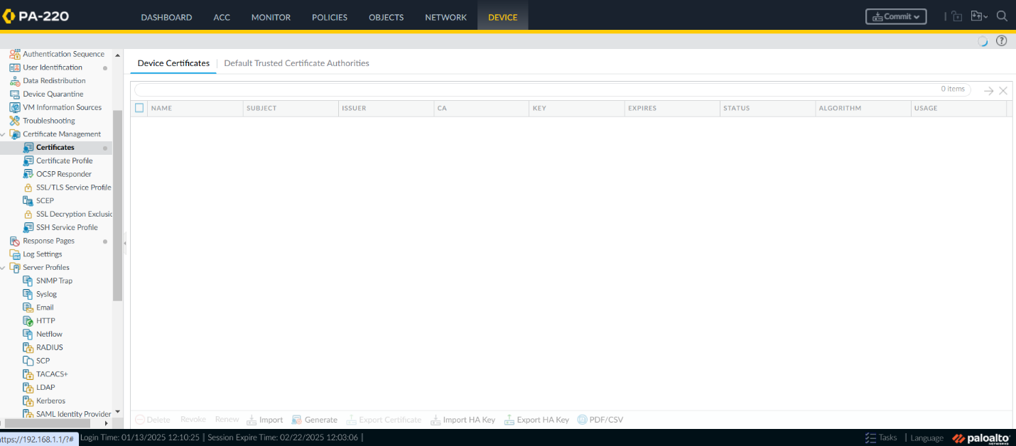

1. Create a new certificate for our Root Certificate. Make sure to add a Common Name and check the box for Certificate Authority. Adding Certificate Attributes is optional, but we added a Country (US) and an Organization (Palo Alto Networks). Click “Generate” to create the certificate with these settings.

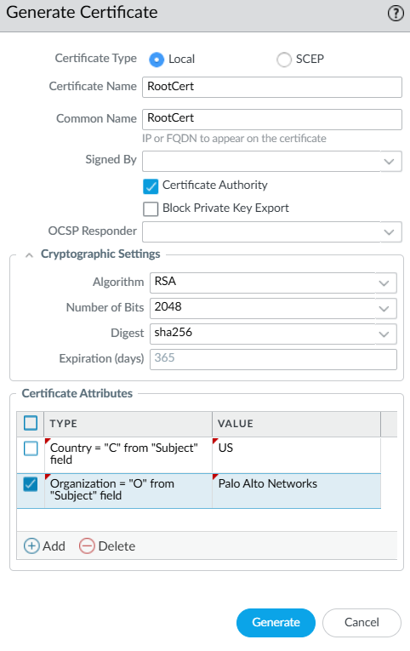

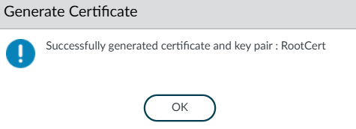

1. Create another new certificate for our Intermediate Certificate. Make sure to add a Common Name and check the box for Certificate Authority. Then, open the drop down labeled “Signed By” and select our previously created RootCert. Once again, the Certificate attributes are optional but make sure to keep constant if you add.

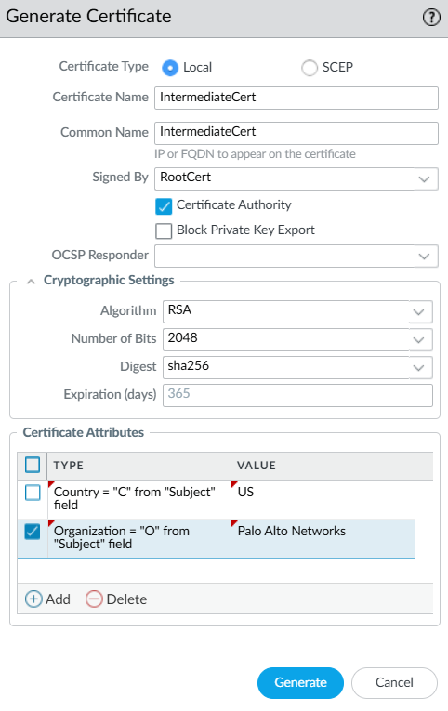

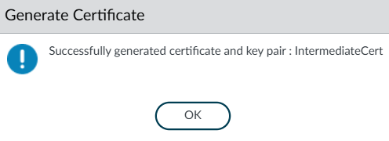

1. Create one final certificate as our Server Certificate. Make sure the box for Certificate Authority is NOT checked for this certificate. For the Common Name, use the IP of our Dynamic DHCP Client. Then, open the drop down labeled “Signed By” and select our previously created IntermediateCert. Once again, the Certificate attributes are optional but make sure to keep constant if you add.

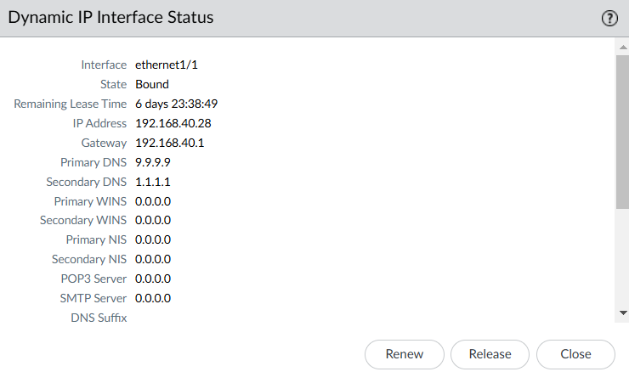

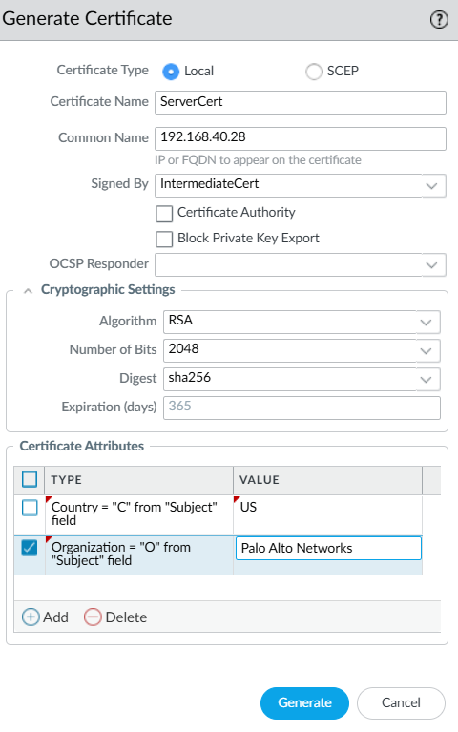

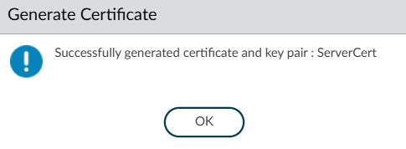

This is what our Device Certificates tab should look like. Notice the indents.

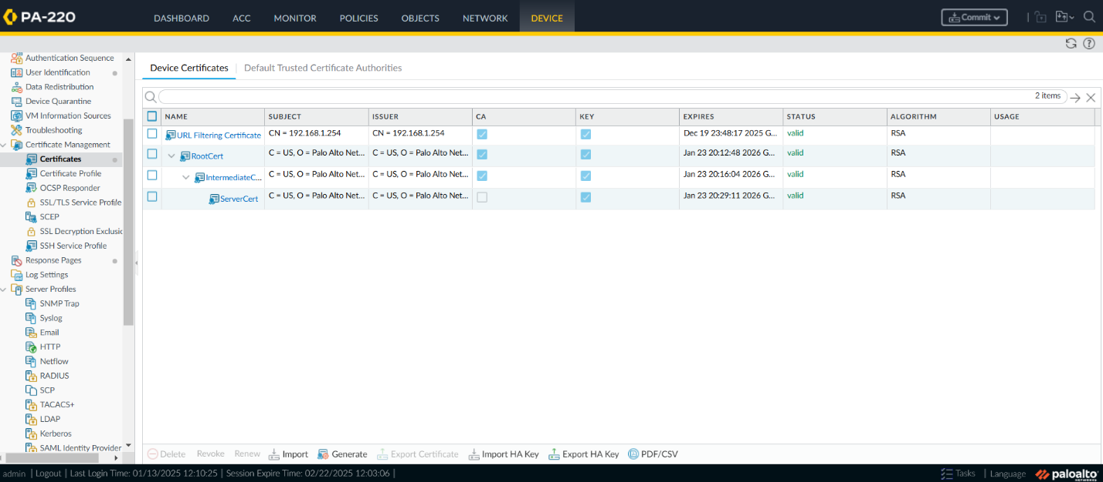

1. Next, go to Device > Certificate Management > SSL/TLS Service Profile. Click “Add” located on the bottom bar.

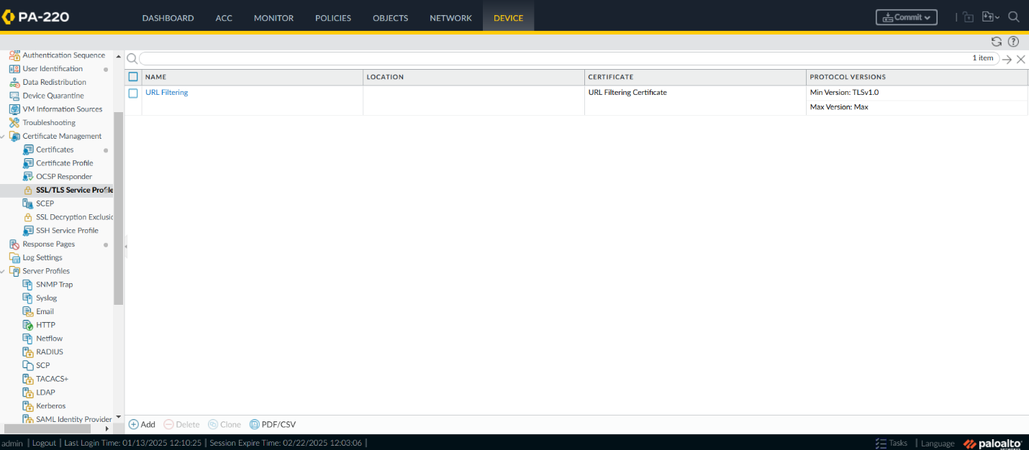

1. Set a name for our profile, then select “ServerCert” from the Certificate dropdown. For protocol settings, make sure that the Min Version is set to the version with the smallest version number (in our case, v1.0), and make sure the Max Version is set to Max. Click “Ok” when finished.

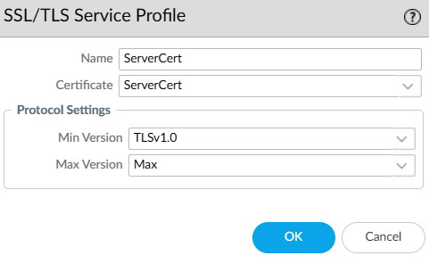

1. Go to Device > Certificate Management > Certificate Profile, then click “Add” on the bottom bar.
2. Set a name for the Certificate Profile. Then, click “Add” under CA Certificates.

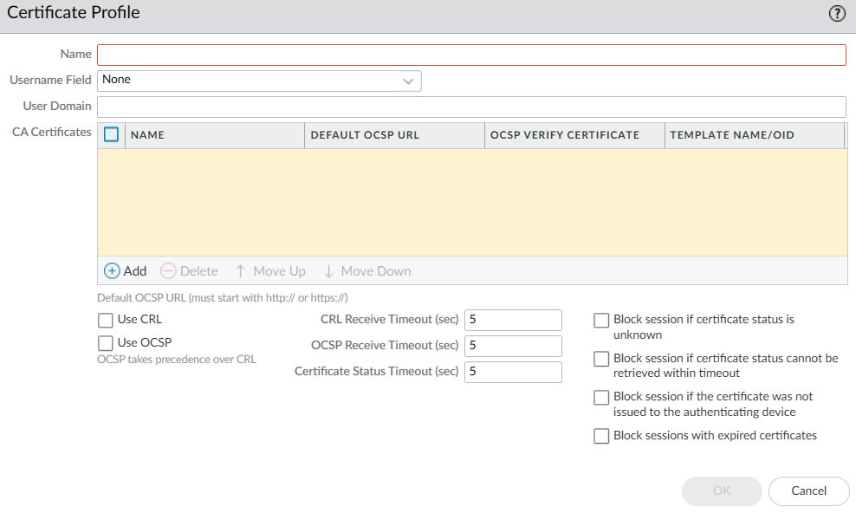

1. Select “RootCert” for our CA Certificate and click “Ok”. Do the same thing again except add our IntermediateCert.

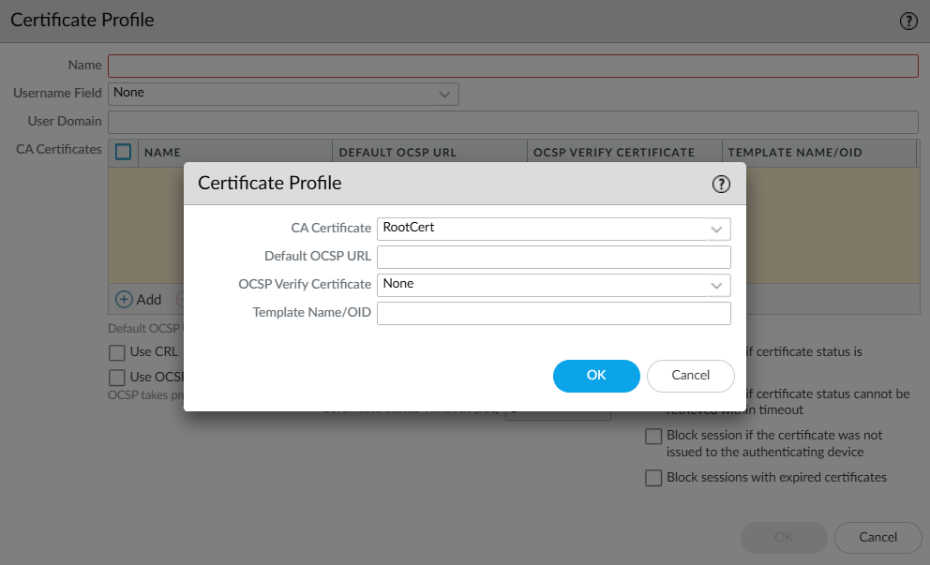

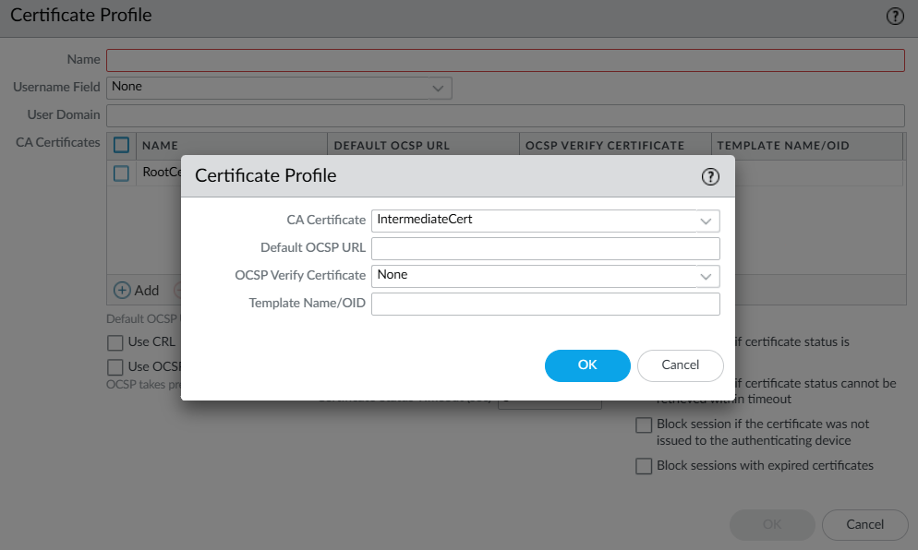

1. Change our Username Field to “Subject” since we are not using LDAP/RADIUS authentication.

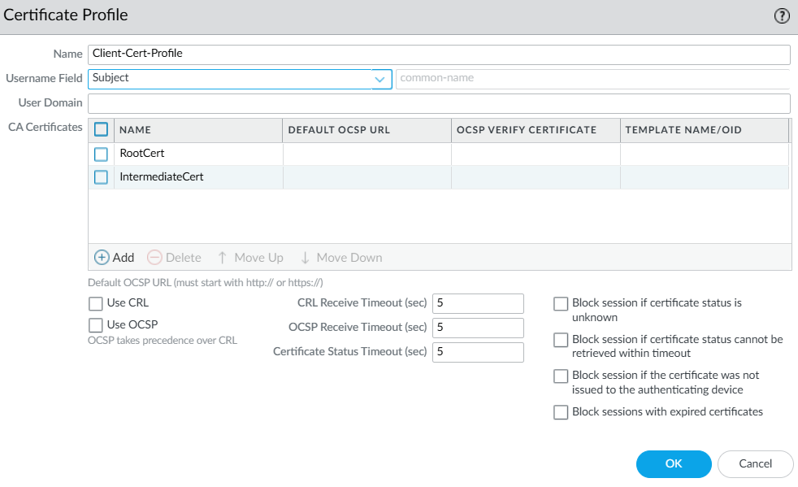

This is what our Certificate Profile tab should look like after our configurations.

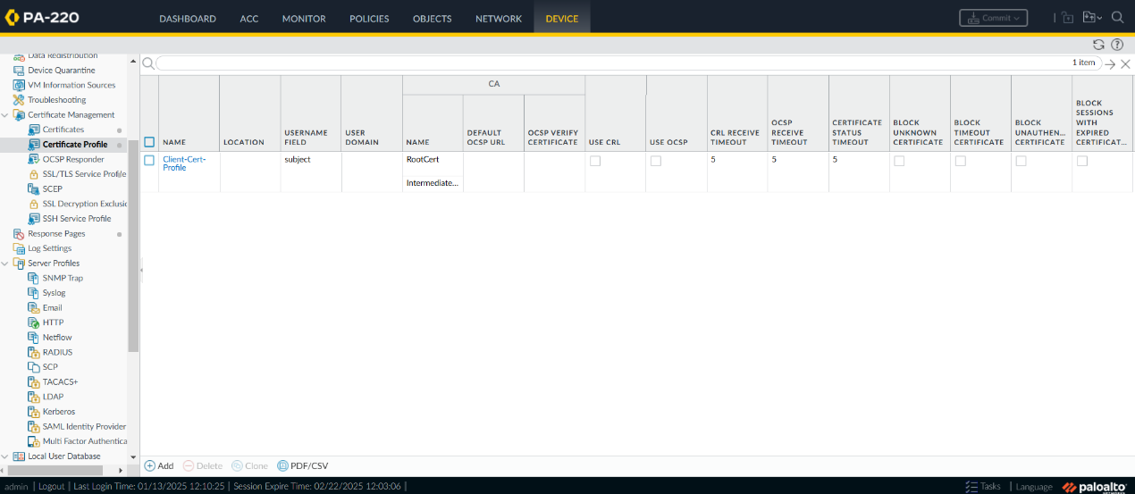

1. At this point, it is a good idea to download our certificates and install them onto our external machine. Select each certificate one by one and click “Export Certificate” on the bottom bar. Once the certificates are sent to our external machine, go into our File Explorer and follow the instructions to download, or go into MMC as we described in our previous lab.



1. Our next step is to go to Device > Authentication Profile. Click “Add” on the bottom bar.

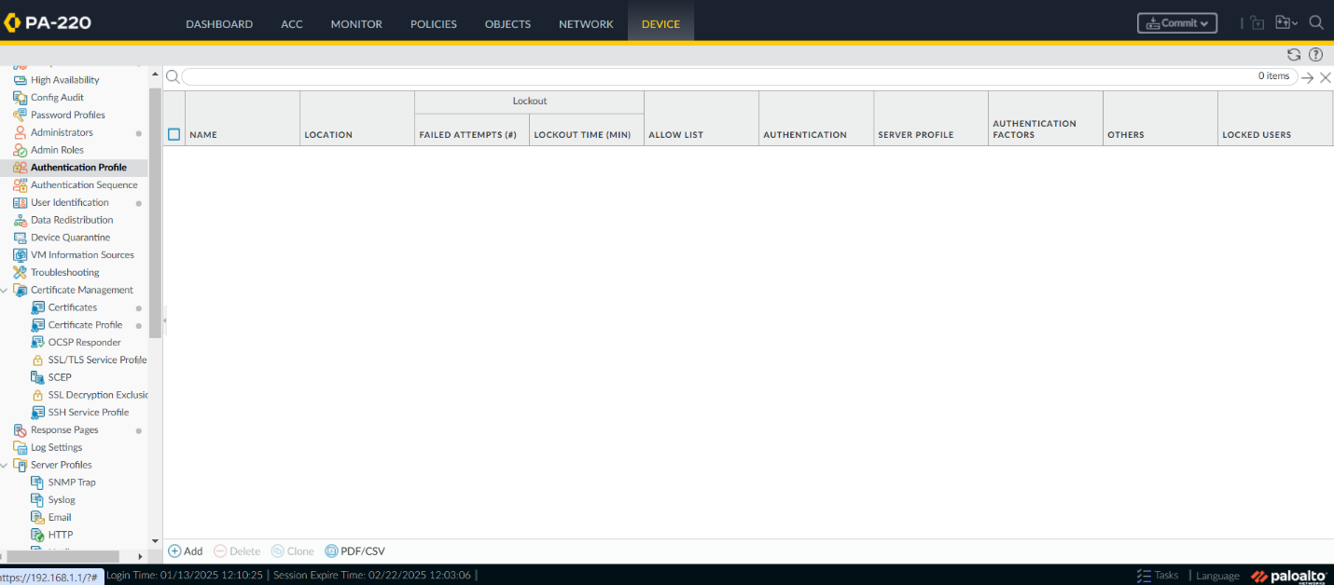

1. Under the Authentication tab, create a name for our Authentication Profile and make sure Local Database is selected.

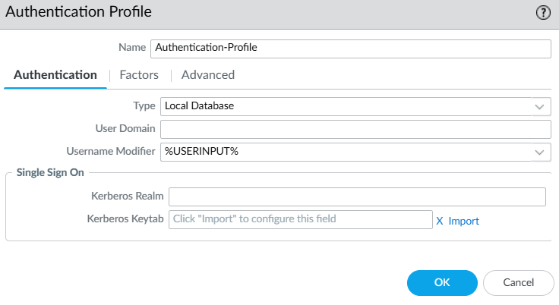

1. Go to the Advanced tab and click “Add” under the Allow List. Select all users for this.

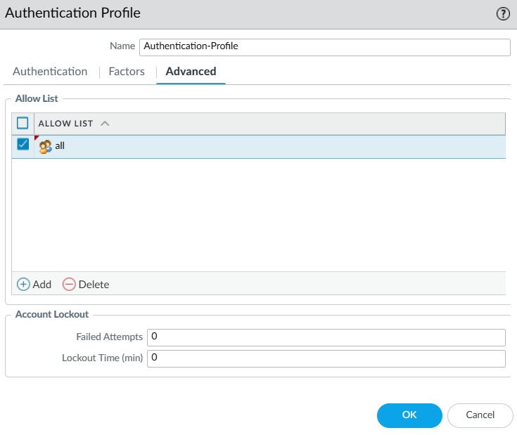

This is what our Authentication Profile tab should look like.

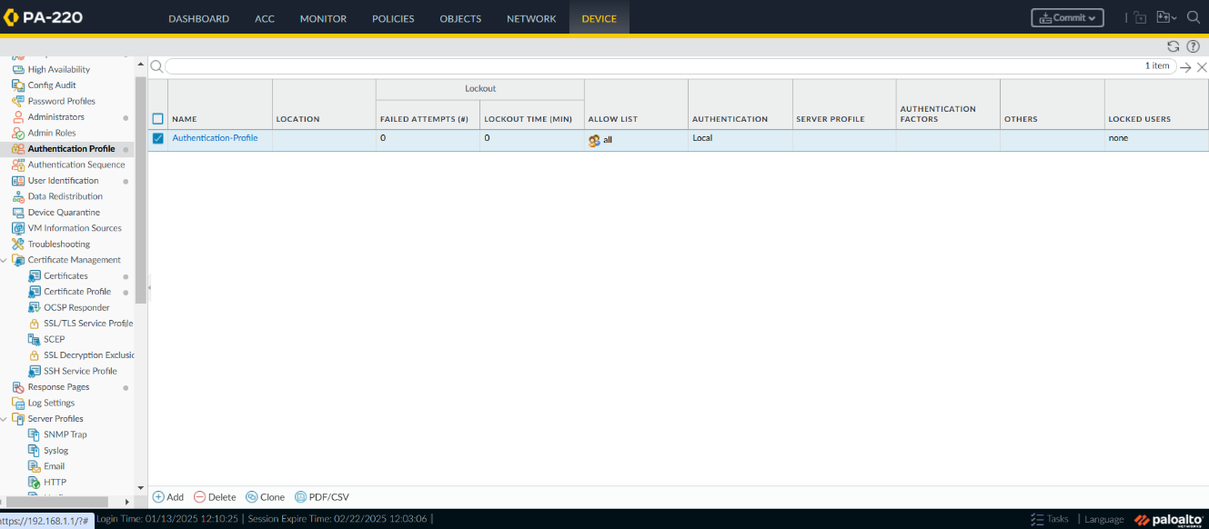

1. Go to Network > Interfaces > Tunnel. Click “Add” on the bottom bar.

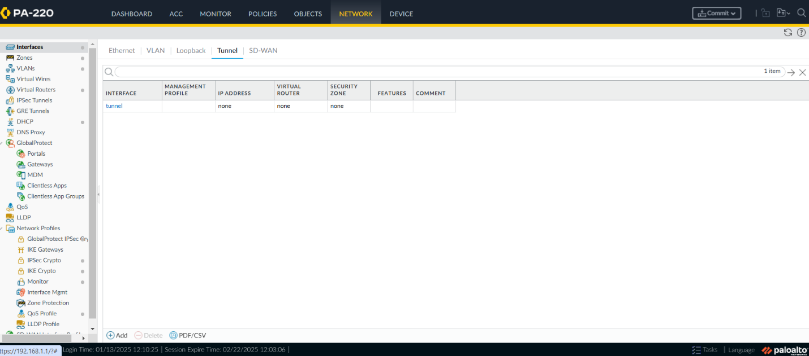

1. In the Config tab, add a number to uniquely identify this Tunnel Interface. For our Security Zone, we will not have a VPN option already set up. Instead, we will click the option to create a new Security Zone.

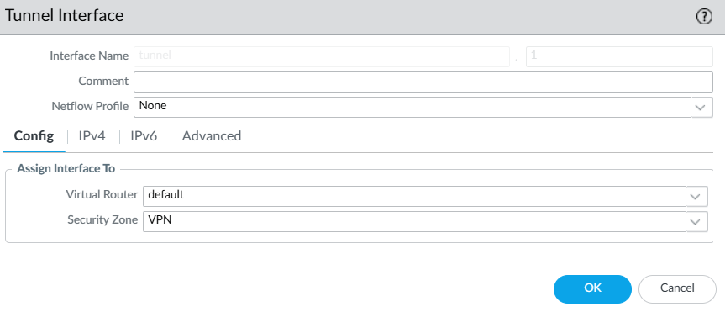

1. Set a name for our Zone, then under Interfaces, click “Add” and select our newly created tunnel. Then, go back to the previous picture and confirm that the Security Zone is “VPN”.

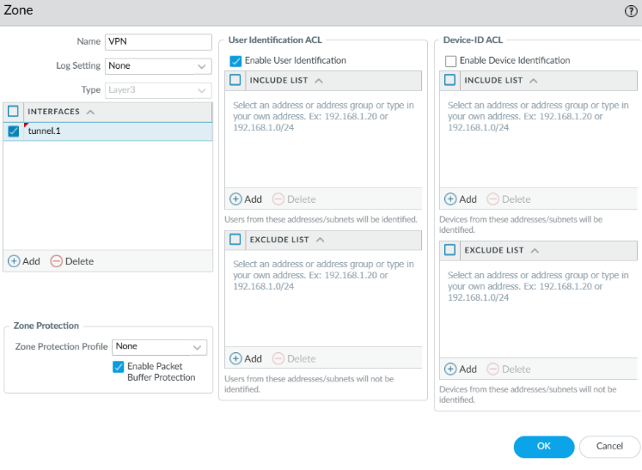

1. Go to Policies > Security. Click “Add” on the bottom bar.

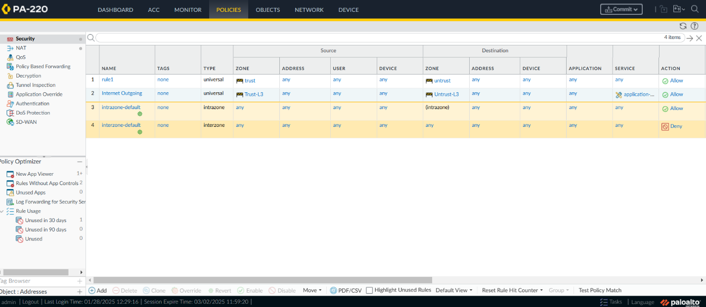

1. Set a name for our new zone to direct all our VPN traffic. Make sure the Rule Type is Universal.

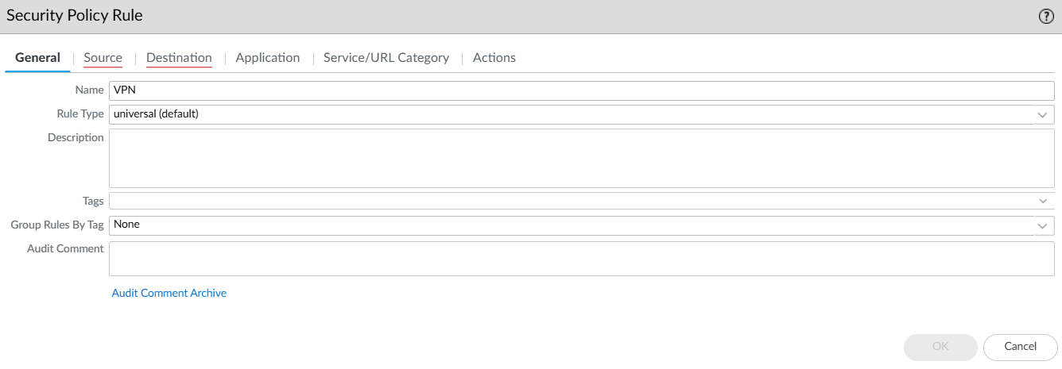

1. Under the Source tab, set the Source Zone to “VPN”. Under the Destination Tab, set our Destination Address to “Any”.

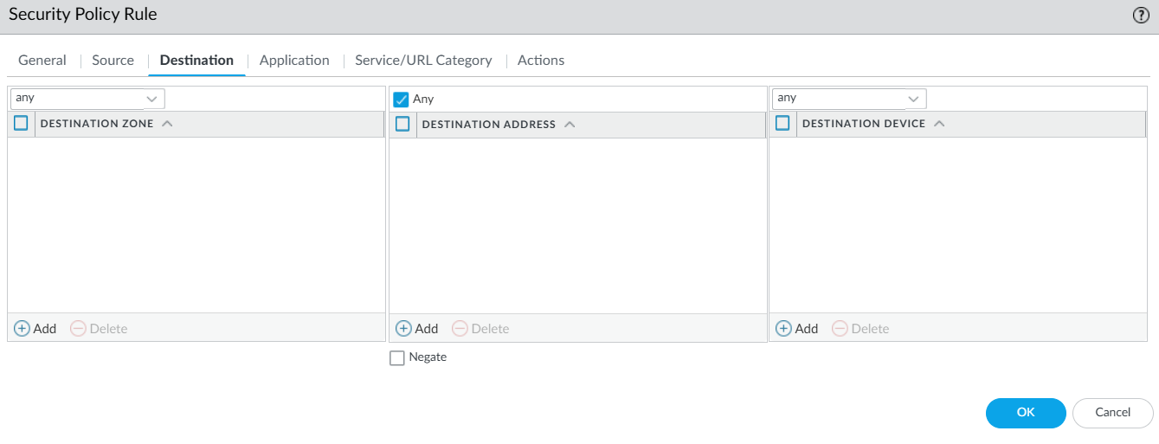

1. Go to Network > GlobalProtect > Portals. Click “Add” on the bottom bar.

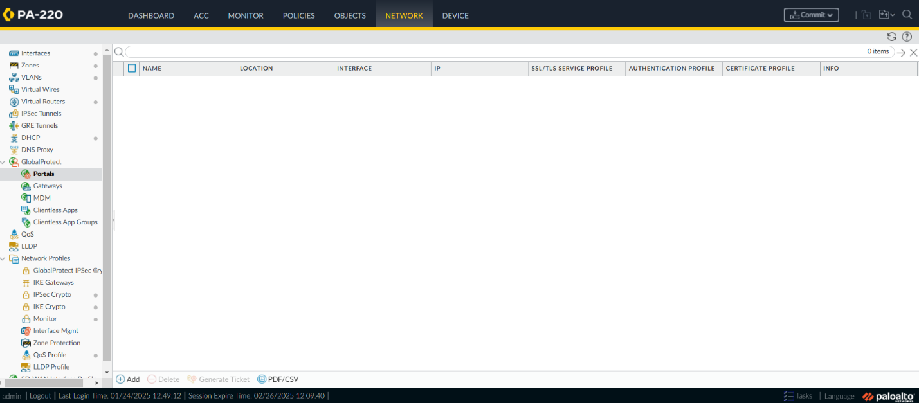

1. Under the General tab, set a name, then make sure the interface is set to our ethernet interface connected to the internet. Since we are using DHCP, the section for IPV4 Address can be set to “None”.

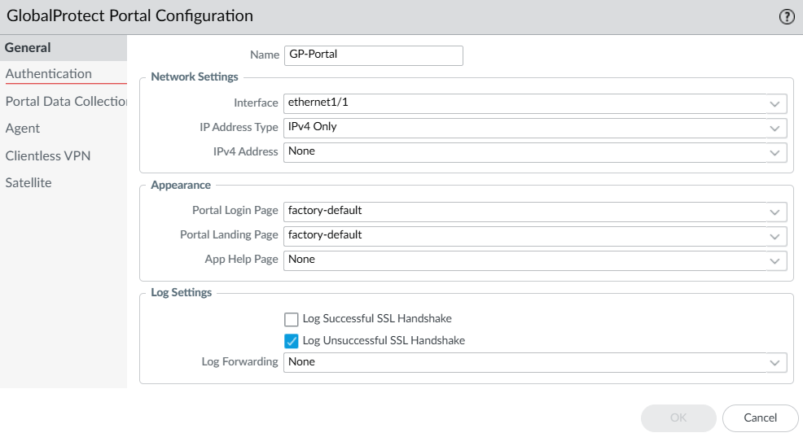

1. Switch to the Authentication tab. Select “ServerCert” from the SSL/TLS Service Profile dropdown. Click “Add” under Client Authentication.

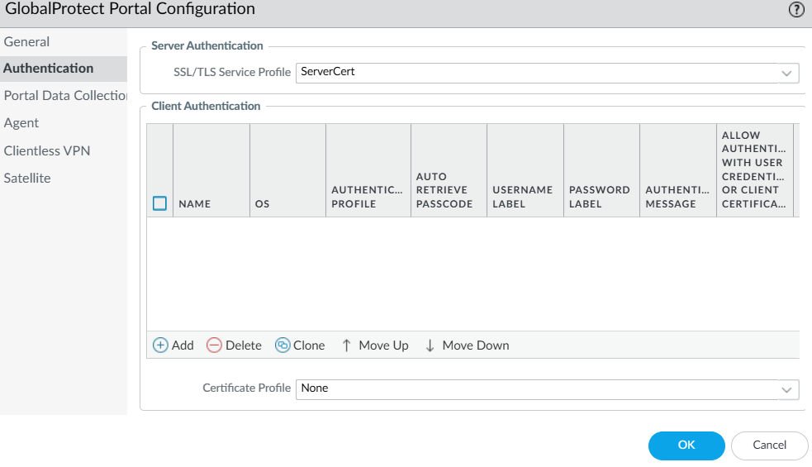

1. Set a name and make sure OS is set to “Any”. We also chose to set Allow Authentication with User Credentials OR Client Certificate to “Yes”, which gives our system slightly less security but also less of a chance for problems due to certificate errors. Click “Ok”.

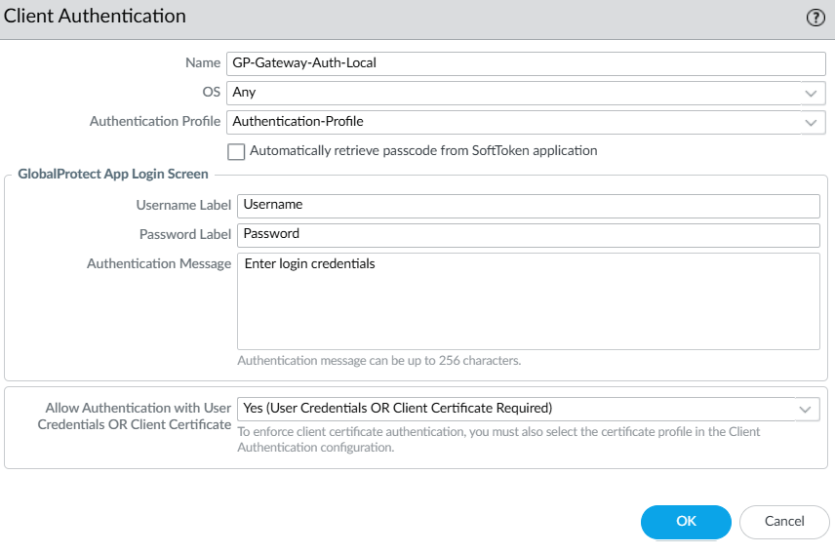

1. Switch to Agent tab. Under Agent, click “Add”.

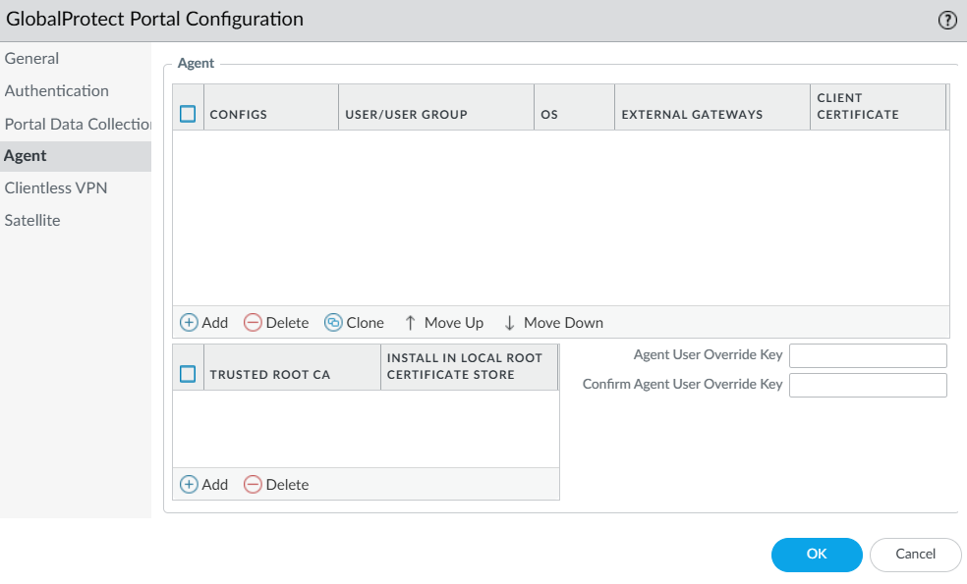

1. Under the Authentication tab of the new Configs popup, set a name. Make sure to set Certificate to Encrypt/Decrypt Cookie to our Root Certificate.

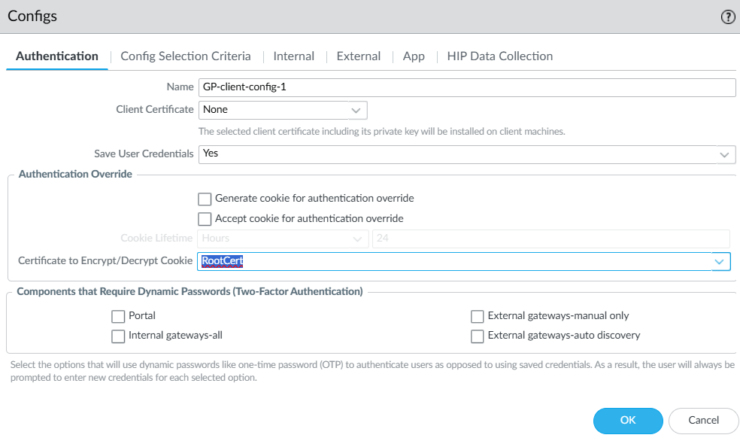

1. Switch to the External Tab. For External Gateways, click “Add”.

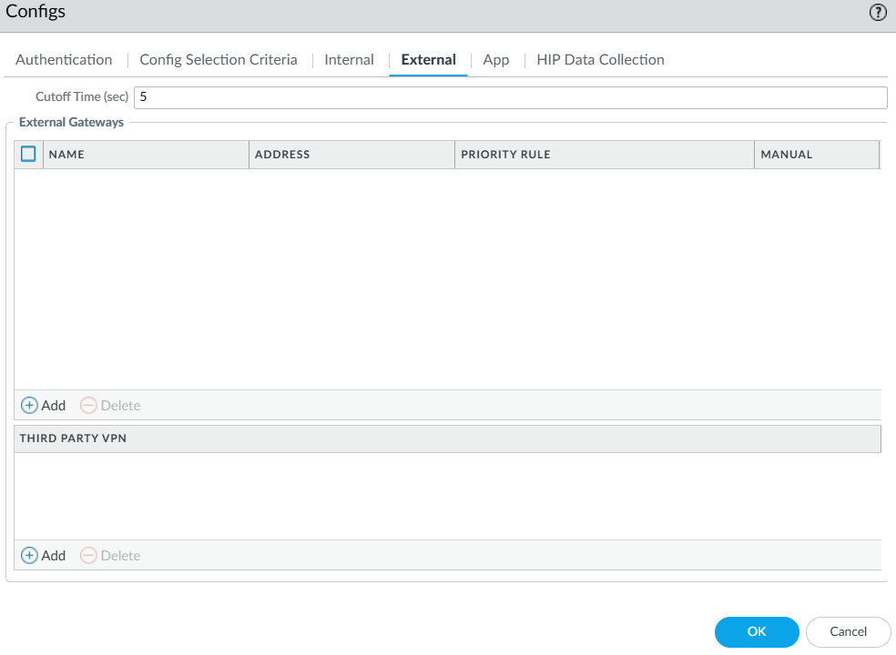

1. Set a name for our External Gateway, then select IP and input the IP of our Dynamic DHCP Client that we used earlier for our Server Certificate. Click “Add” and select “Any” for Source Region, then set its priority to “Highest.” Click “Ok”.

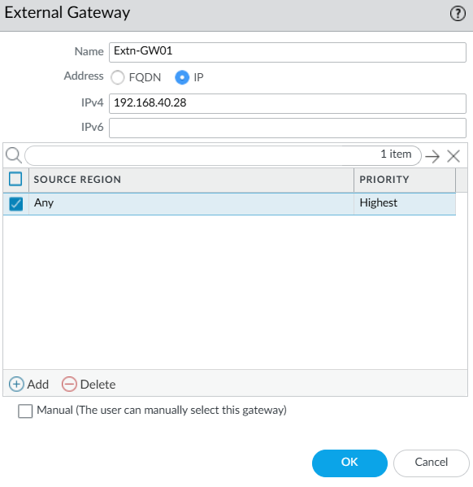

1. Switch to the App tab, where we will change two settings. The first is switching the Connect Method to “On-demand”. The second is to change Allow User to Continue with Invalid Portal Server Certificate to “Yes”.

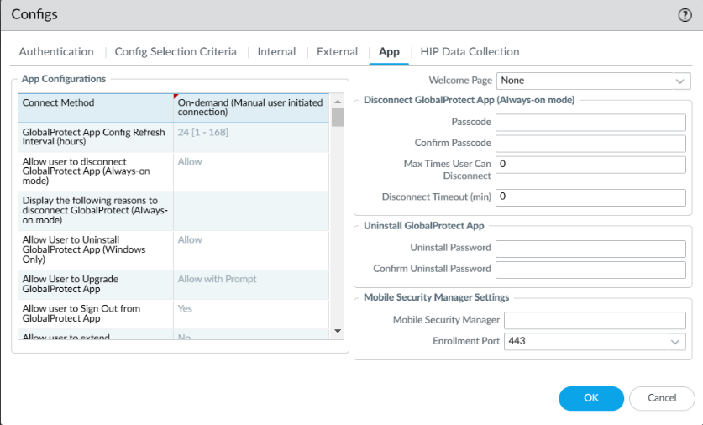

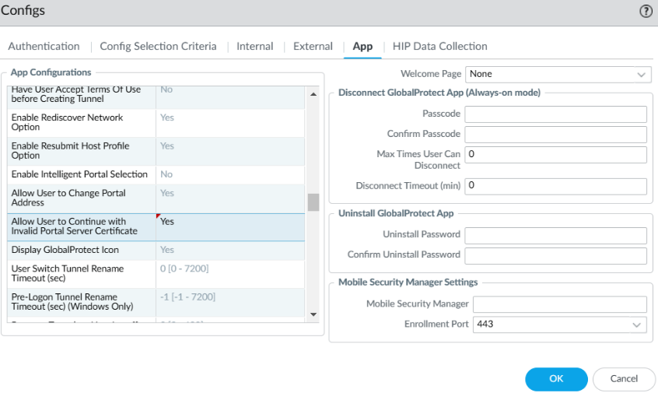

1. Under Trusted Root CA, add both “RootCert” and “IntermediateCert” and check “Install in Local Root Certificate Store” for both. This is what our final configuration for the Agent Tab should look like. Click “Ok”.

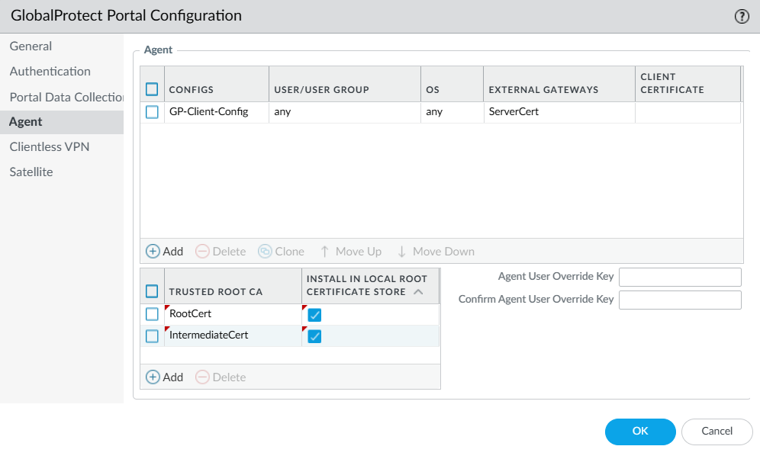

1. Go to Network > GlobalProtect > Gateways. Click “Add” on the bottom bar.

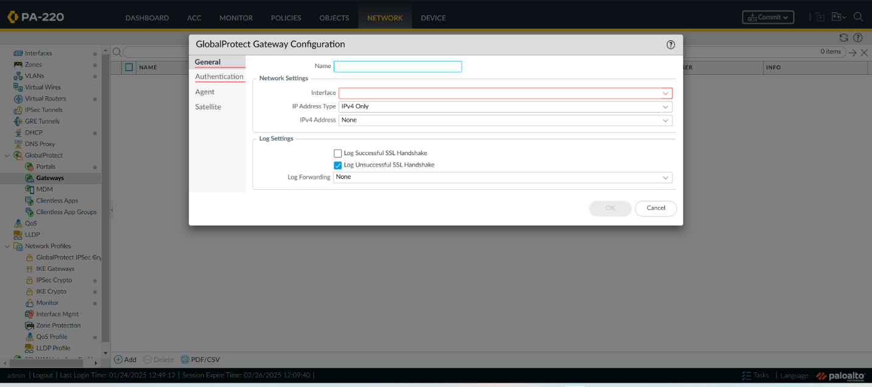

1. In the General Tab, set a name. For our interface, make sure it is our ethernet interface that is connected to the internet.

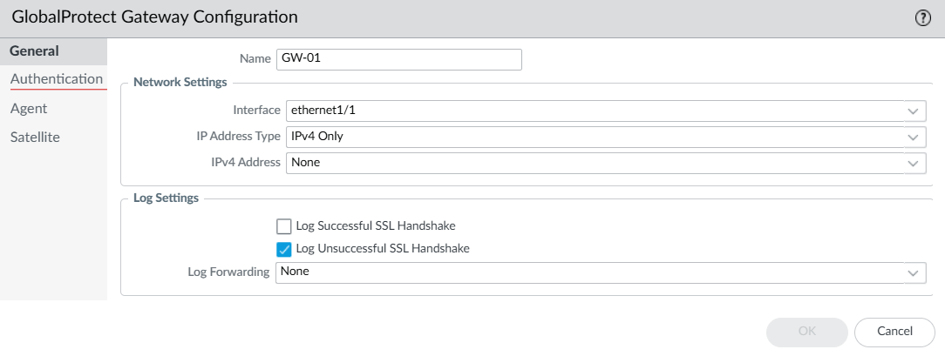

1. Under the Authentication tab, set a name and make sure OS is set to “Any”. For Allow Authentication with User Credentials OR Client Certificate, set this to “Yes”.



1. Switch to the Agent tab. Under the Tunnel Settings category, make sure Tunnel Mode is checked, set the Tunnel Interface to the one that we created, and check the box titled Enable IPSec.

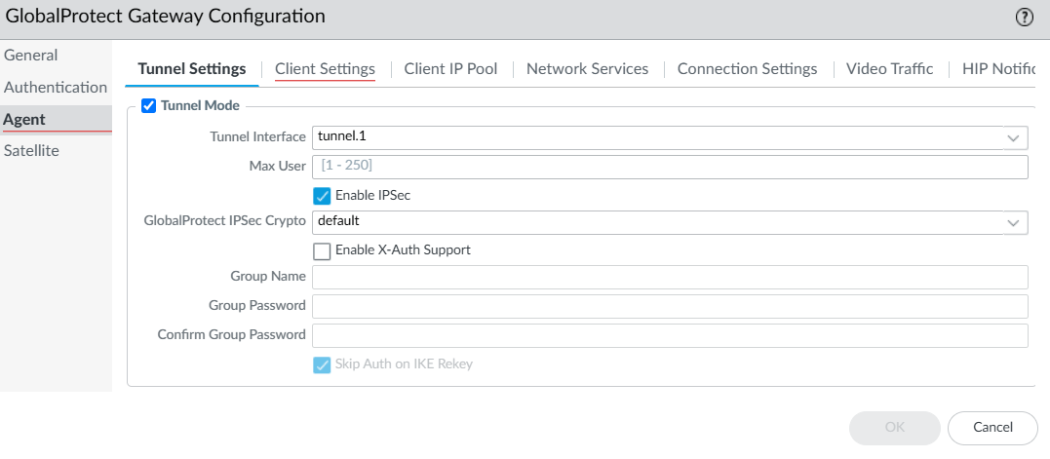

1. Switch to Client Settings tab. A Configs popup will appear. Under Config Selection Criteria, set a name, then check “Any” for the OS.

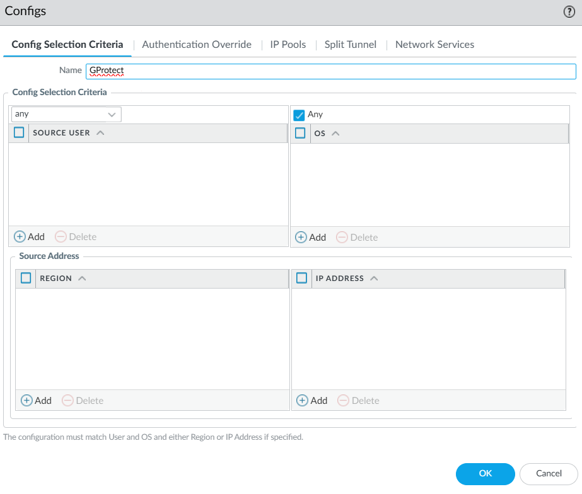

1. Switch to IP Pools tab. Set a range of IPs to be allocated on the internal network. Click “Ok”.

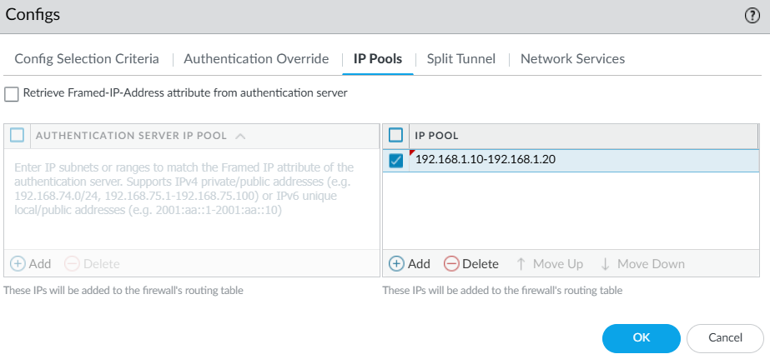

1. Go to the Network Services tab under Agent. Make sure the Inheritance Source is set to your ethernet port connected to the internet. Also make sure that the Primary and Secondary DNS are both set to “inherited”. Click “Ok” when all settings have been changed.

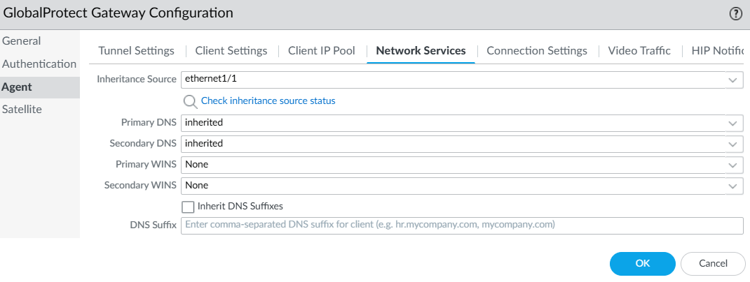

1. Go to Device > Local User Database > Users. Click on “Add” on the bottom bar. Set a username and confirm a password.

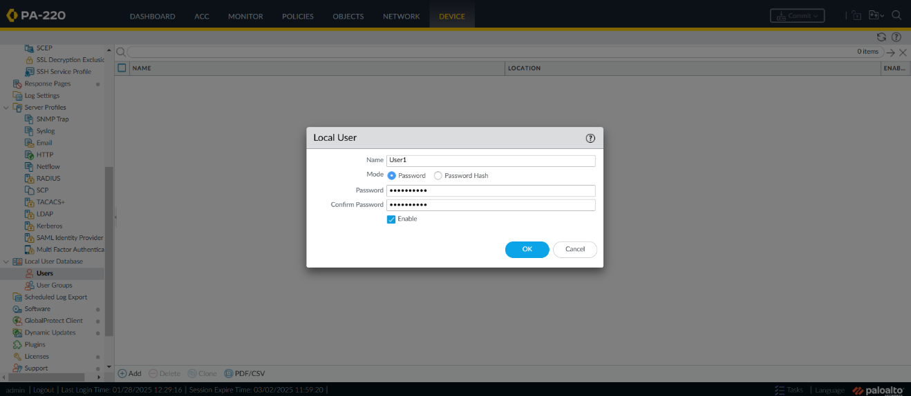

1. To make sure we have no issues with downloading GlobalProtect, go to Device > GlobalProtect Client and click “Check Now” on the bottom bar.

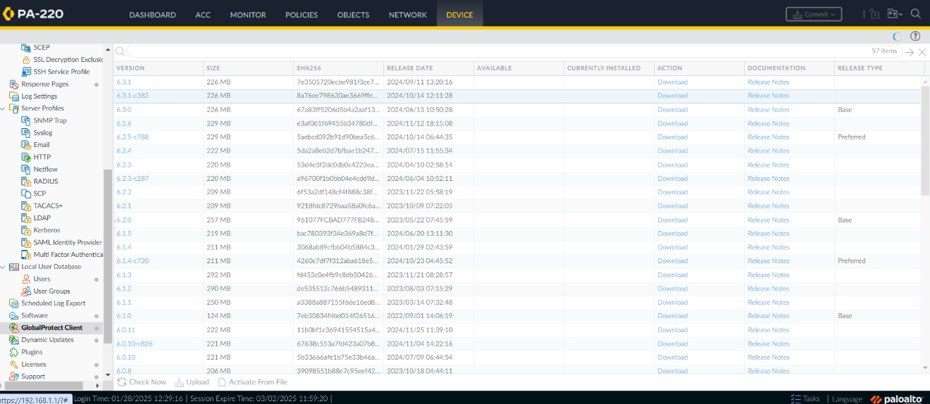

1. Click “Download” on the latest version, that being 6.3.2 for us.

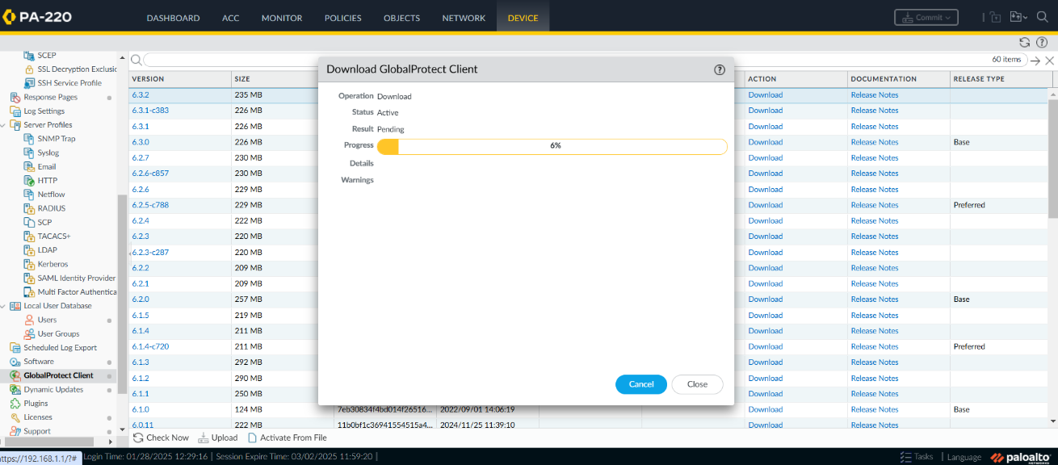

1. Once downloaded, click “Activate”. You will get an extra popup with a warning. Click “Yes”.

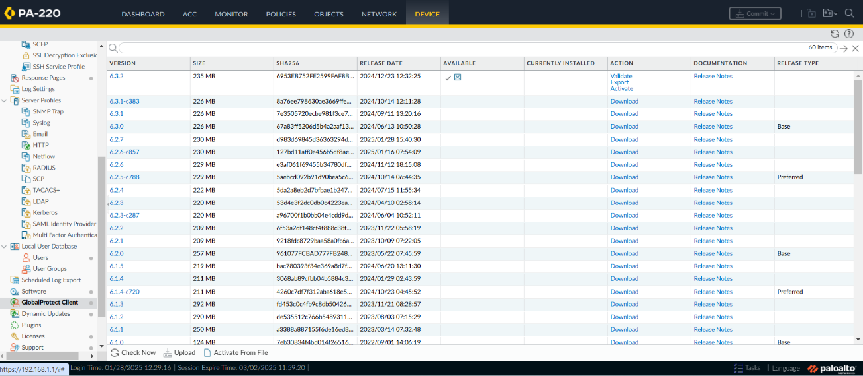

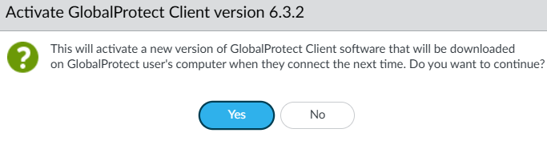

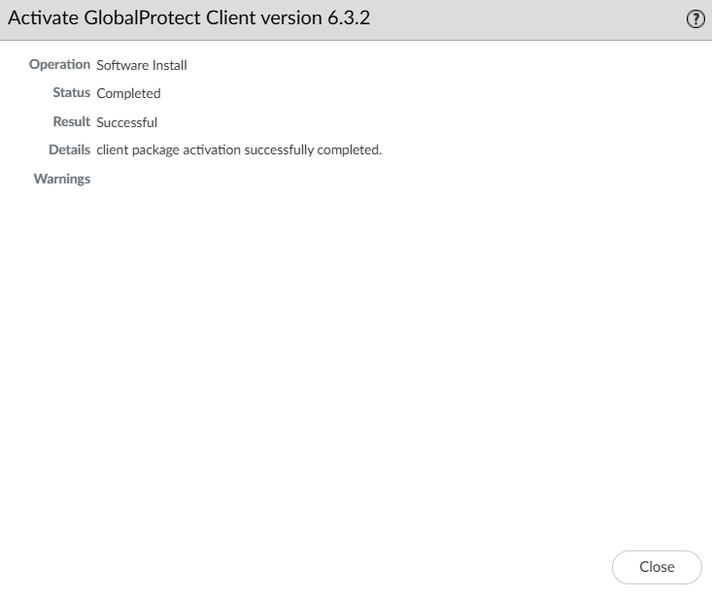

1. Commit all changes.

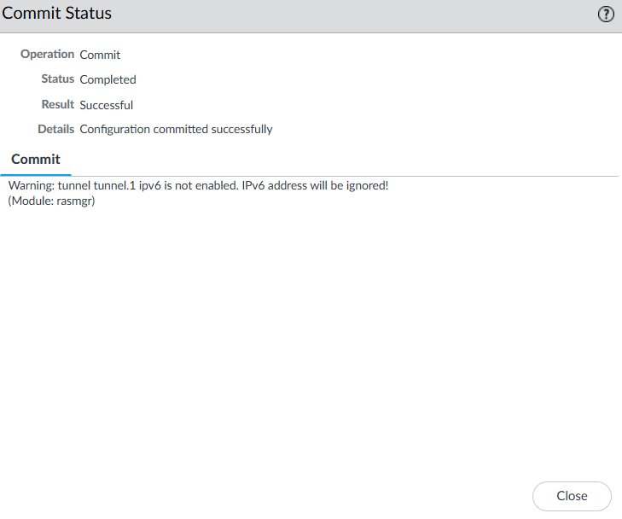

1. Type in our Dynamic DHCP Client IP into our web browser on our external device. You will then be prompted to sign in. Use the username and password we just created on our firewall’s local database.

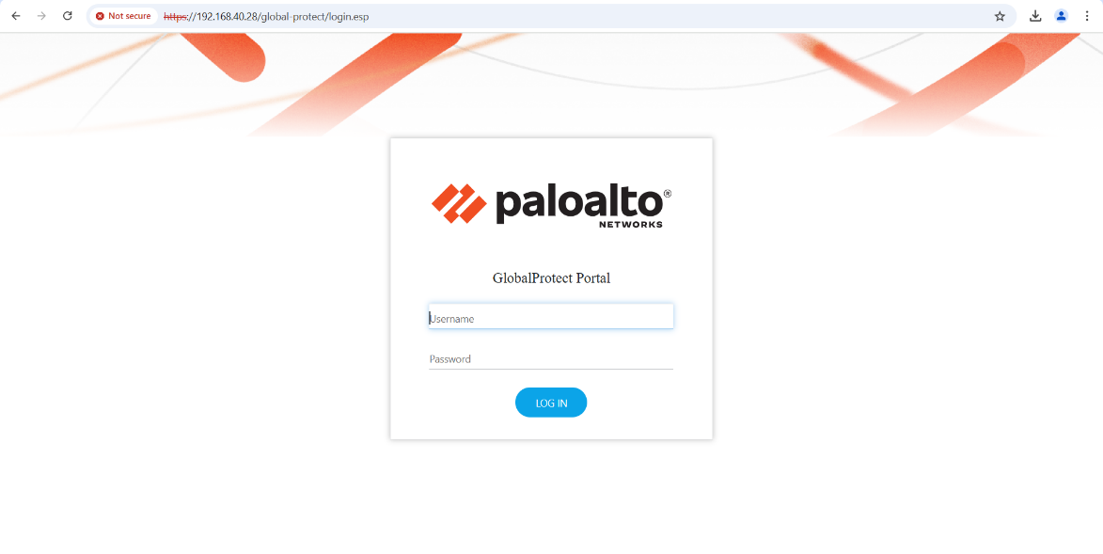

1. Download the appropriate version of GlobalProtect by clicking on the link.

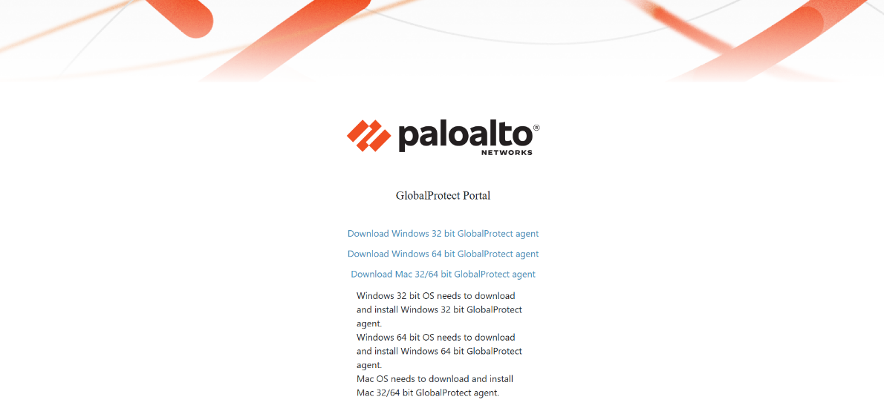

1. Open the downloader from File Explorer. Follow all prompts to install GlobalProtect.

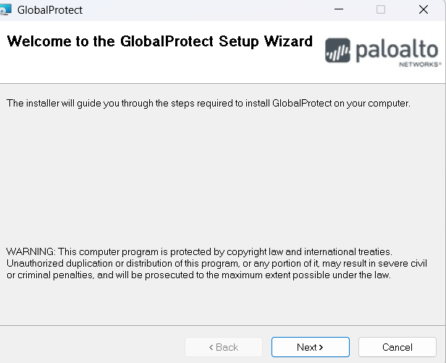

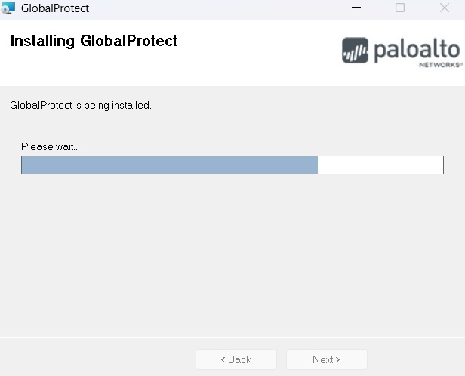

1. Open GlobalProtect.

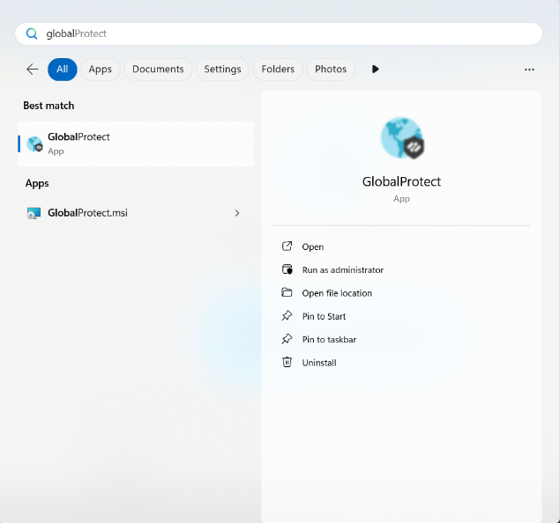

1. Click “Get Started”.

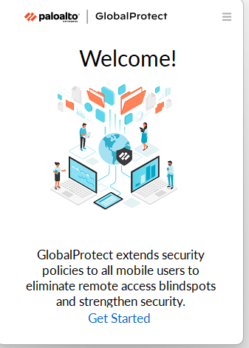

1. Add our Dynamic DHCP Client IP as one of our Portals under Connections tab.

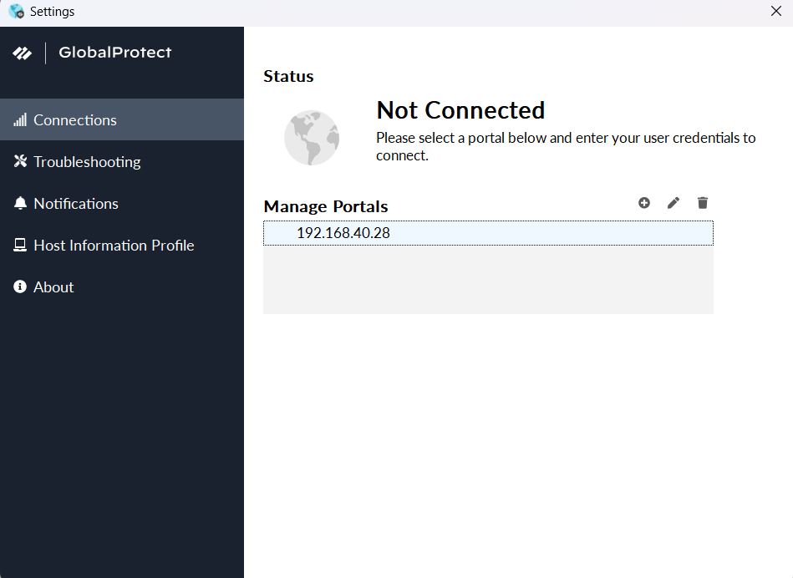

1. Go into our internal device’s Settings. Under System > Remote Desktop, make sure that the switch is turned on. If not, turn it on. At this time, also make sure all Windows firewalls are turned off.

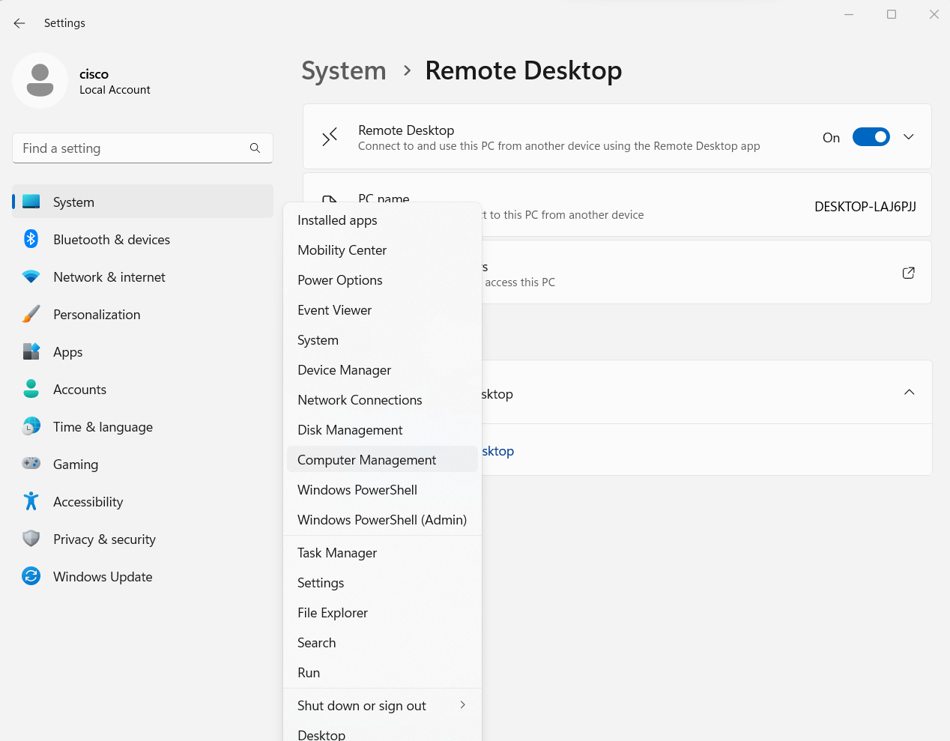

1. Go into our external device’s Computer Management application. Under Computer Management (Local) > System Tools > Local Users and Groups > Users, add a new user. We also chose to make sure that the password never expires.

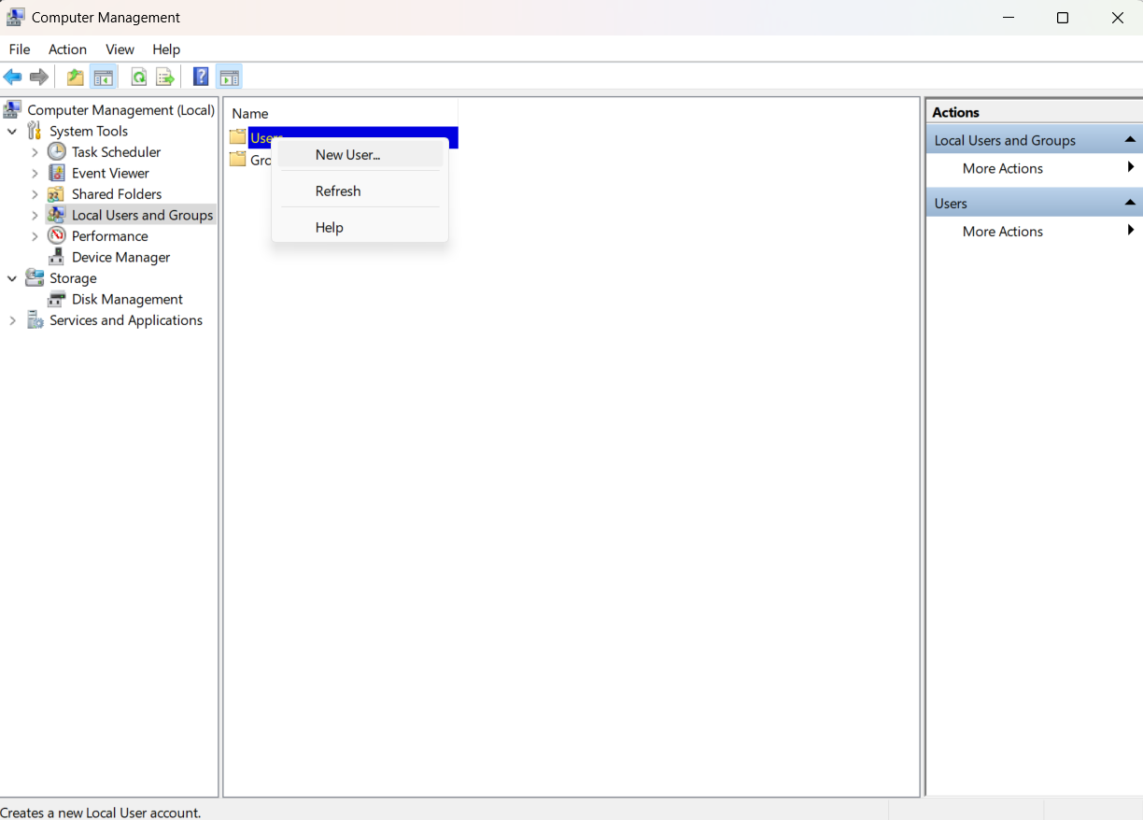

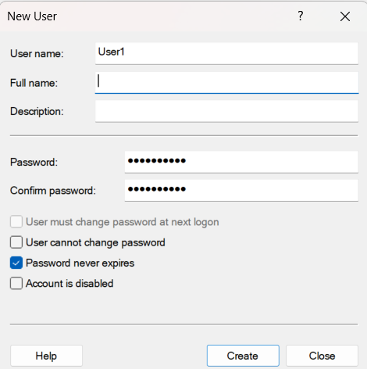

1. For our newly created user, go into Properties by right clicking.

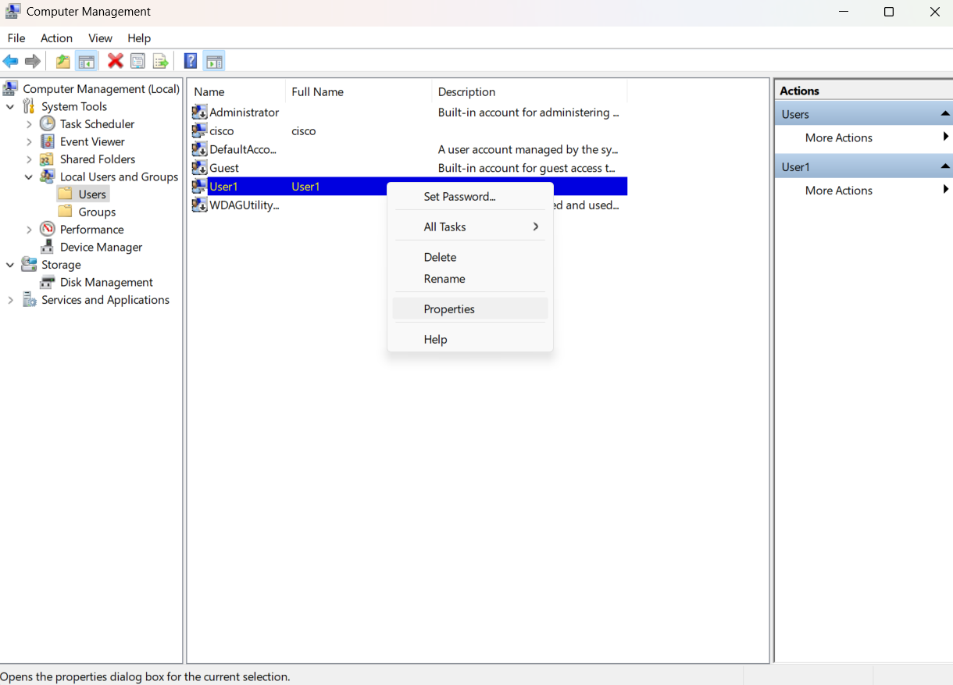

1. Go to the Member Of tab for our user’s properties and click “Add”. You’ll get another popup box for Select Groups. Click “Advanced…”.

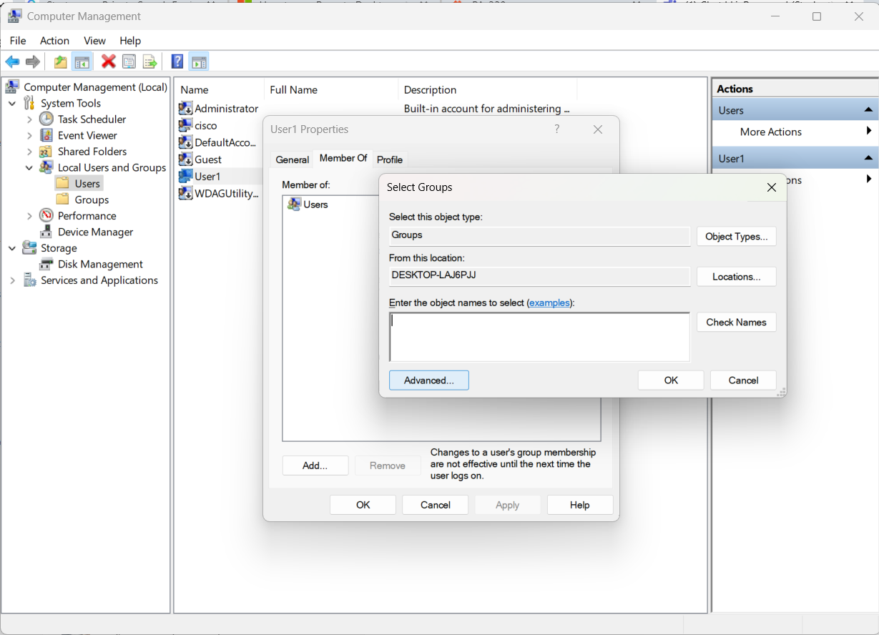

1. Click “Find Now” and select the one titled “Remote Desktop Users”.

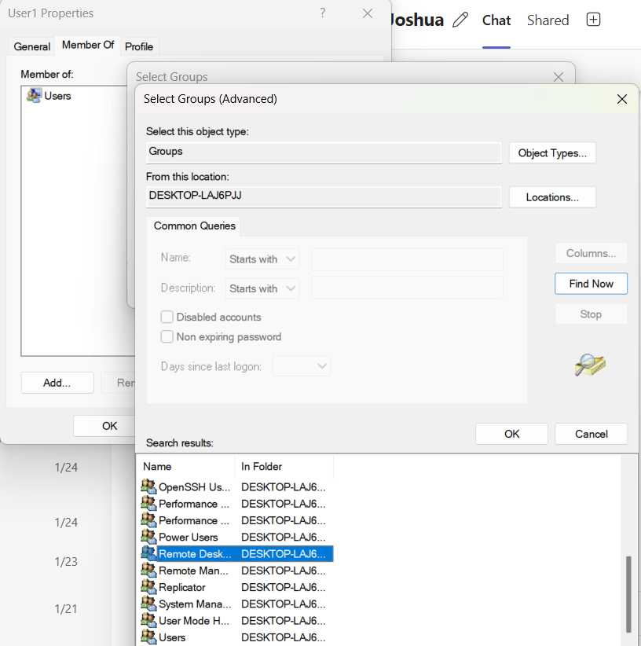

1. Click “Ok” to finish applying changes to Computer Management.

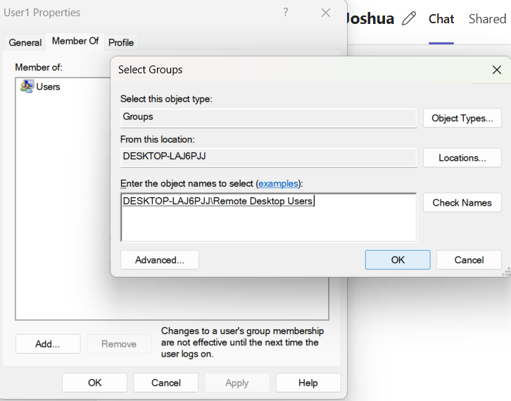

1. Finally, use our username and password stored on our PA220 and click “Connect”.

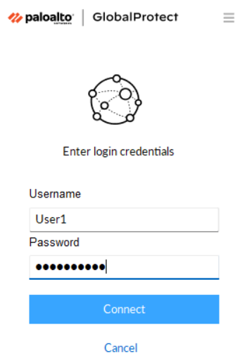

The result should be that you are able to remotely connect from an external device to our internal device.

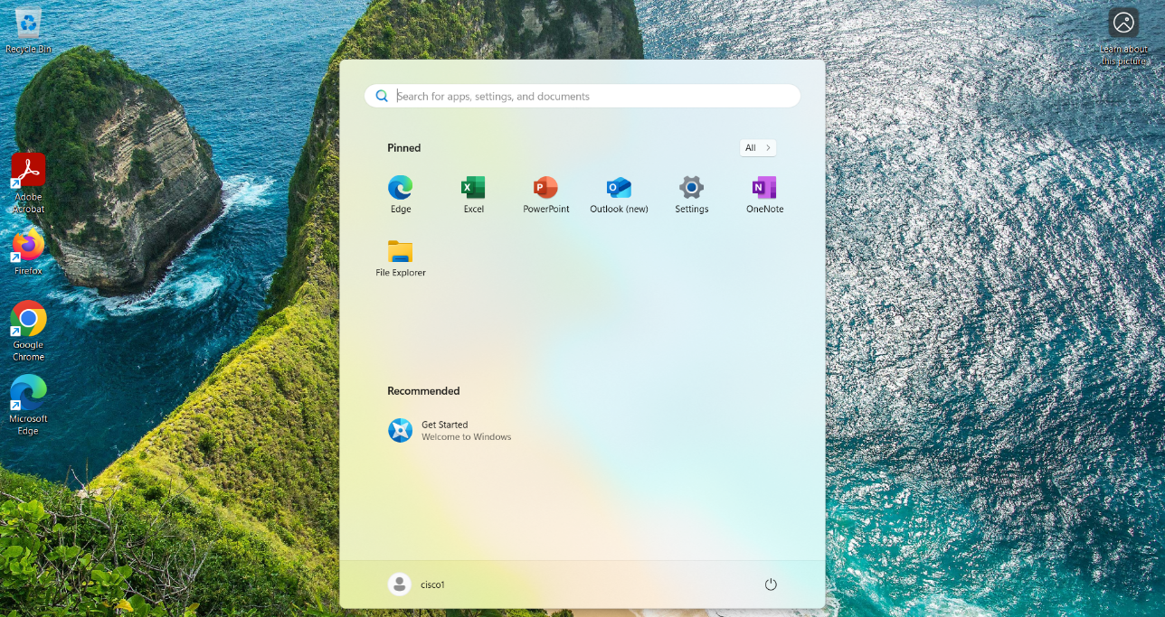

**Problems:**

We encountered many issues while completing this lab. One of the most significant was that in our ServerCert, we originally set the IP of our Common Name as a private IP address that was set to our internal VLAN rather than one that is being distributed by the Dynamic DHCP Client. To fix this issue, we had to delete all instances where we used this ServerCert or this IP, which includes the SSL/TLS Client, the GlobalProtect Portal, and the GlobalProtect Gateway.

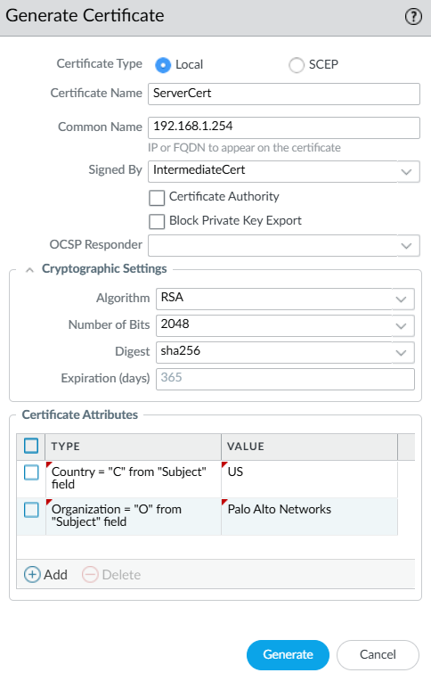

Another major mistake that we made was that we didn’t create a security zone for our VPN traffic initially, and instead opted to direct traffic to an already existing zone called Untrust-L3. After consulting Mr. Mason, we realized that this was causing our network to fail since our firewall was treating the VPN traffic like it was traffic from untrusted sources. Not only that, it is also a security risk for our VPN as it is not benefiting from the access control rules configured on the internal network.

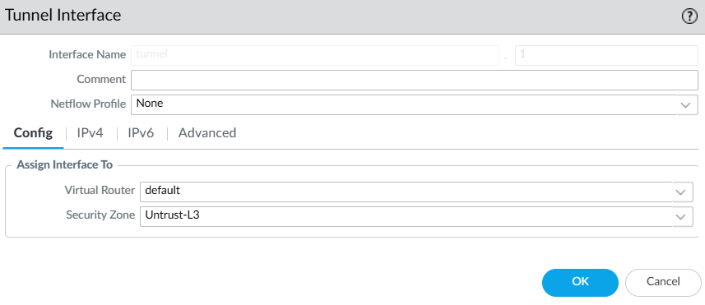

Another more minor issue that we had is that we were having a hard time establishing a connection on our GlobalProtect VPN application due to the server deeming our certificates invalid. With the help from Mr. Mason, we made a couple tweaks by not requiring both User Authentication and Client Certificate to be active on the external device at the same time, trading off a little bit of strict security for ease of access.

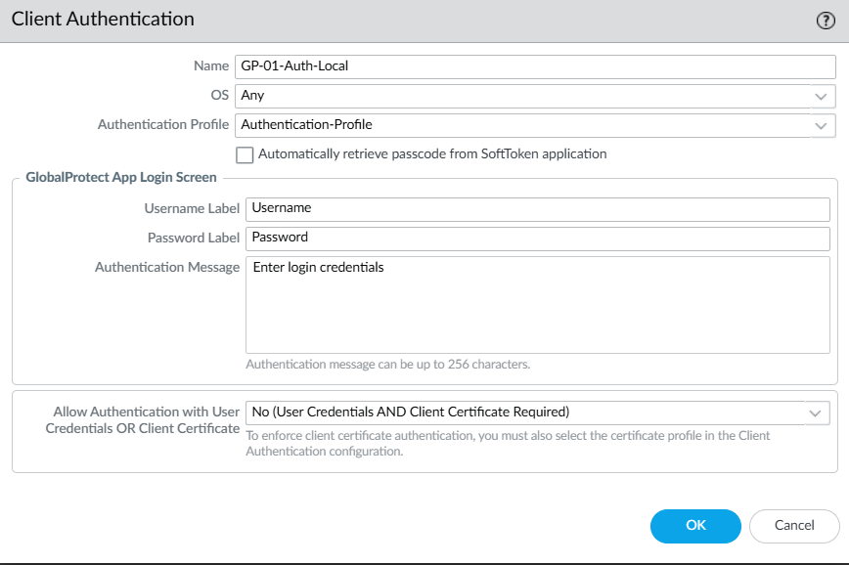

Finally, we were originally getting errors when trying to download our GlobalProtect client versions. Turns out, we weren’t actually downloading the latest version as when we clicked “Check Now”, the actual newest version popped up and after activating it, our GlobalProtect application started to work.

**Conclusion:**

In this lab, we successfully configured a PA220 to support GlobalProtect and remote desktop access. We did this through setting up VPN tunnels, portals and gateways, configuring certificates, and defining security zones. This experience reinforced key networking and cybersecurity concepts in a real-world setting and really emphasized the importance of being able to securely remote access in to another device and network.

**Sign Off:**

